Source:

https://www.youtube.com/watch?v=BwuLxPH8IDs&t=385s

# InStalling & Using TypeScript

* 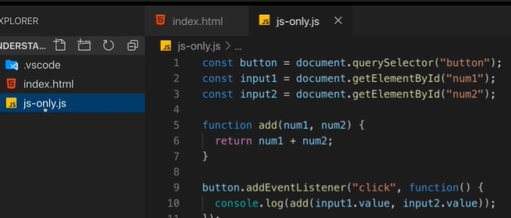
* If number and string, will cat values.
* Fix
* 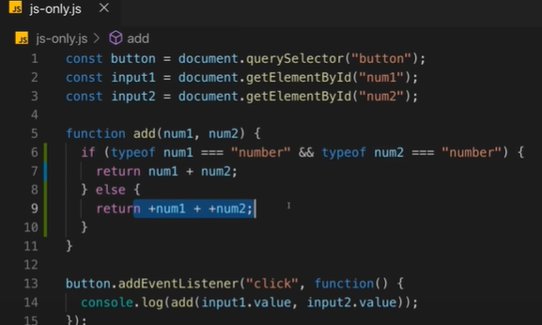
* <https://www.typescriptlang.org/download>
* 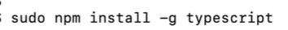
* .ts with file typescript
* As in typescript
* 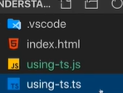
* We can use like this:
* 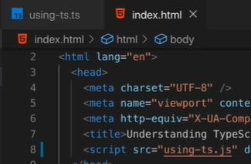
* 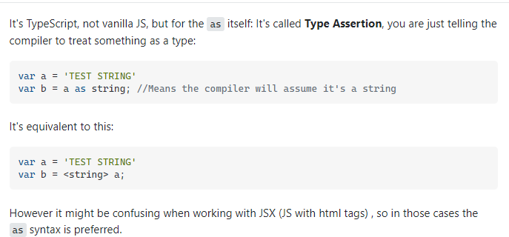

# The advantages of TypeScript:

* 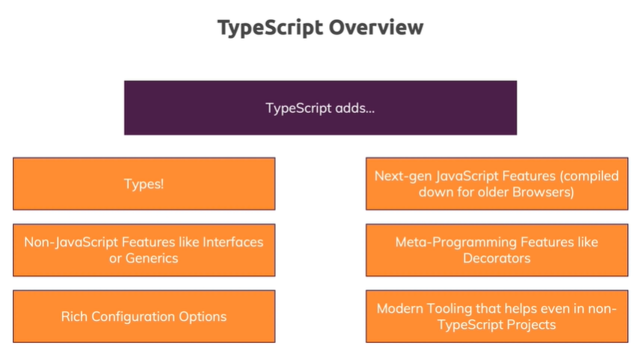

# Course Outline:

* 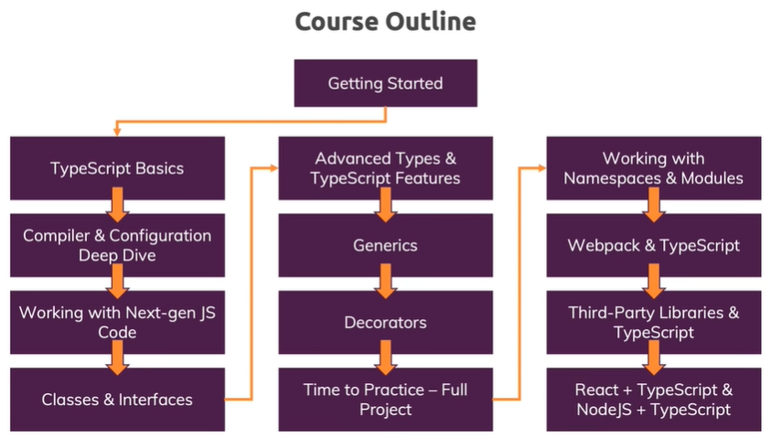

# How to get the Most out of This Course:



# Setting Up our Development Environment:

* Recommend plugin vs code:
* ESLint
* Material Icon Theme
* Path Intellisense
* Prettier -code formatter
* TSLint

# The Course Project Setup

* Install nodejs
* 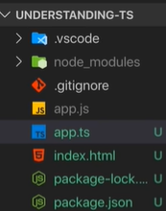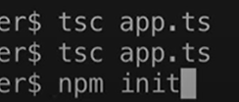

# Using Types:

* Core types:

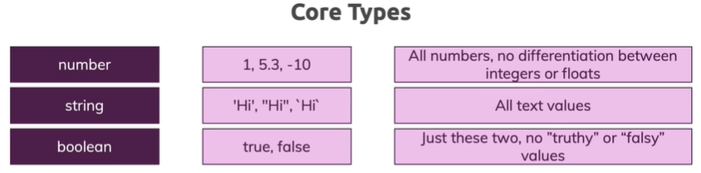

 so we can <script src=”app.js”></script>

* 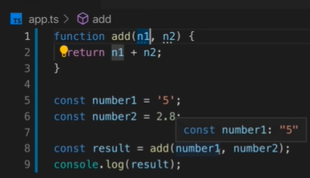just concat string
* 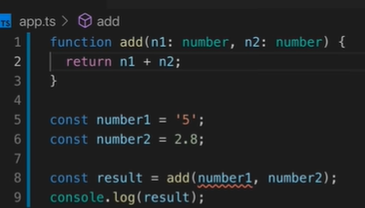error when not number
* TypeScript’s type system only helps you during development (i.e before the code gets compiled)
* Check type: console.log(typeof number1)
* The diference is: JavaScript uses “dynamic types” (resolved at runtime), TypeScript uses “static types” (set during development).
* Boolean
* 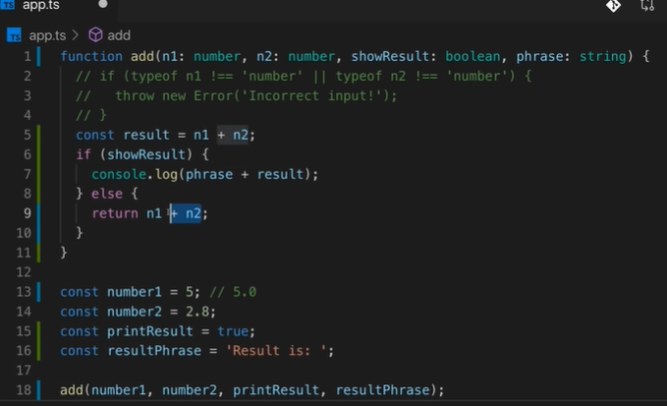

# Type Assignment and Type Inference:

* 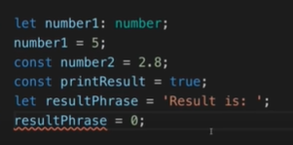

# Object Types:

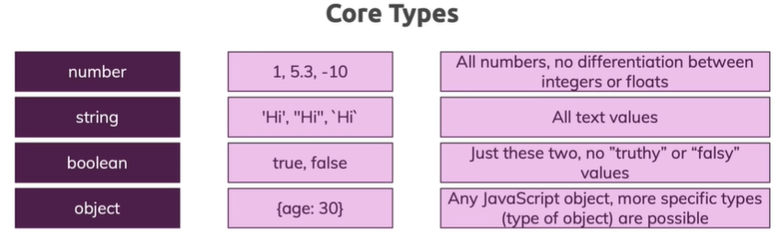

* 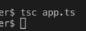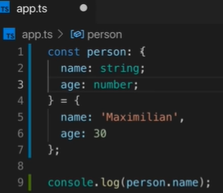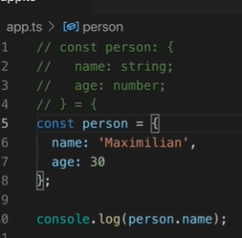

# Array Types:

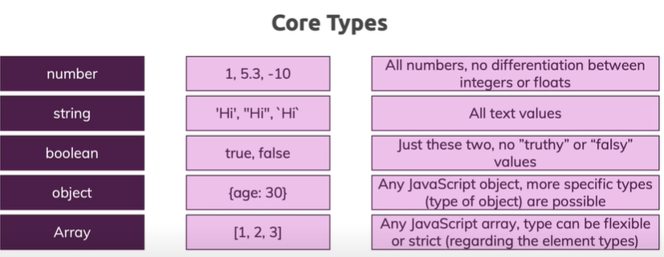

* 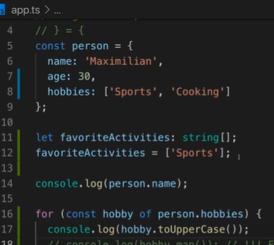

# Tuples:

* 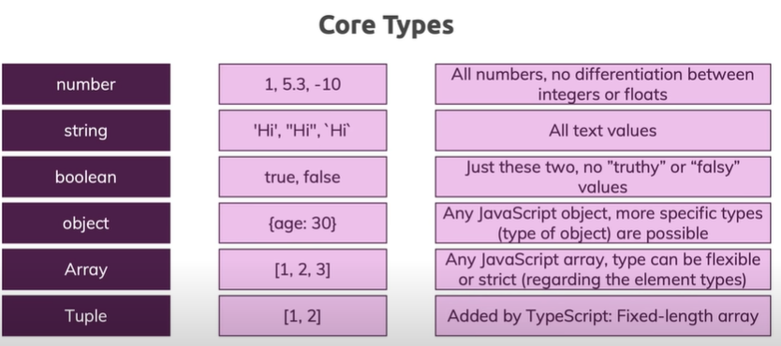
* Number and string in one array:
* 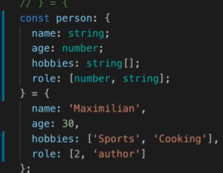
* 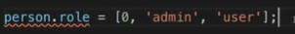 fail

# Enums

* 
* 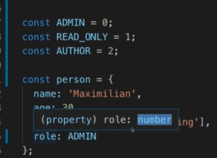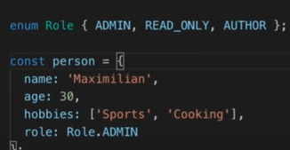
* Often, you’ll see enums with all-uppercase values but that’s not a “must-do”. You can go with ANY value names.

# The any type

* 
* 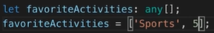

# Union Types:

* Combine
* Typeof use
* 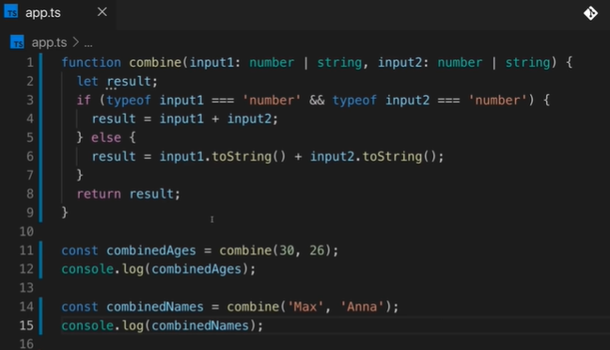

# Literal Types:

* 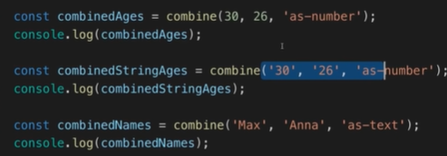
* 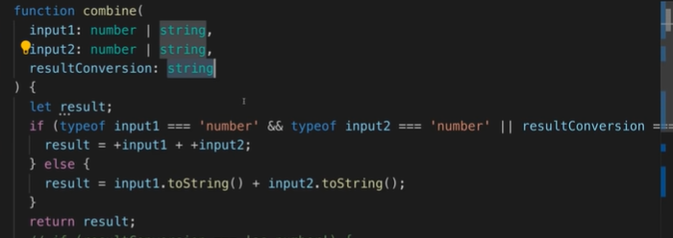
* 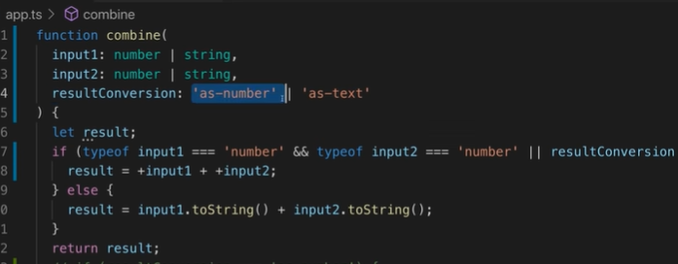

# Type Aliases:

* 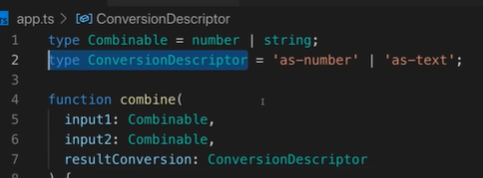

# Function Return Types and Void:

* 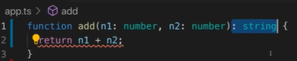
* 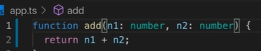
* 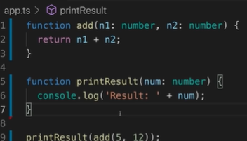
* 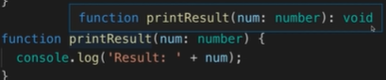 default is void
* 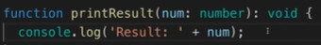
* Undefined return
* 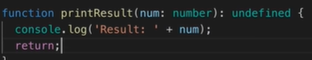
* 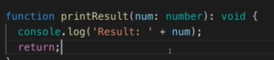

# Function Types:

* Function to variable
* 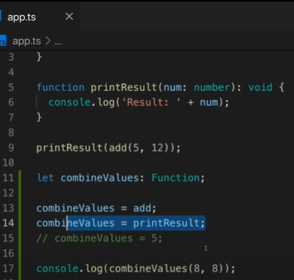
* Arrow function:
* 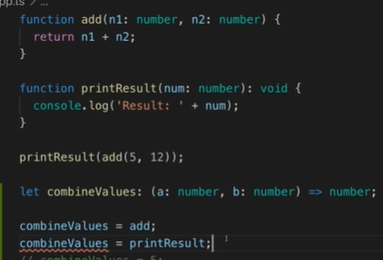

# Function Types and Callback

* Function in parameter
* 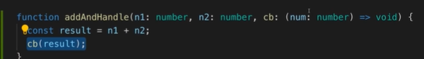
* 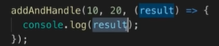

# The unkwon Type:

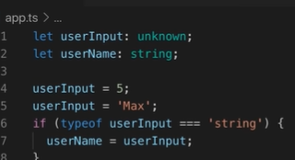

https://mariusschulz.com/blog/the-unknown-type-in-typescript

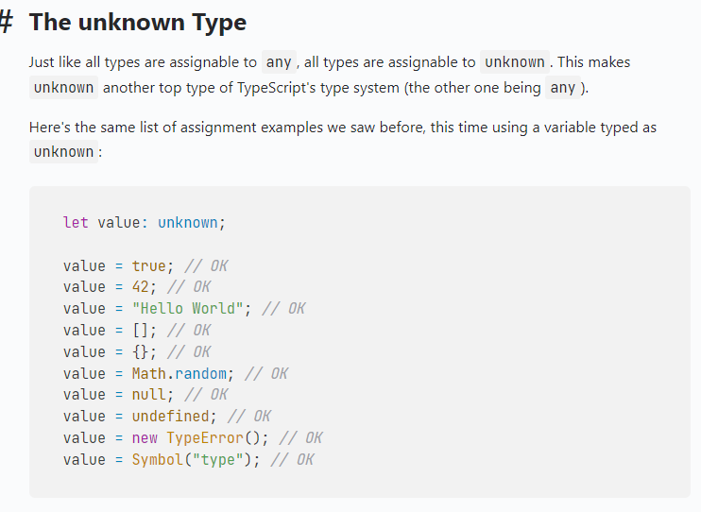

# The never type

* Error
* Never return everything
* 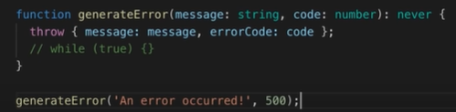

# Wrap up

# Watch Node:

* 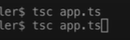 turn on in first and turn off in second call
* DON’T quit this watch mode process whilst developing. You can quit thereafter via CTRL + C.
* 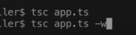
* Save when code done, log error or not error

# Compiling the Entire Project

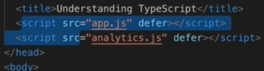

tsc

Tsc –w

# Include and Exclude Files:

* 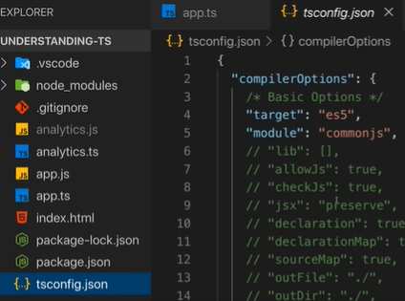
* 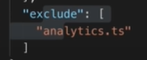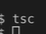
* Before 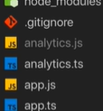after 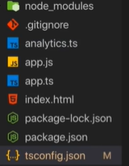
* 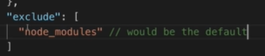
* 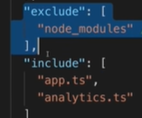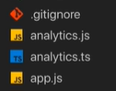

# Setting a Compilation Target:

* 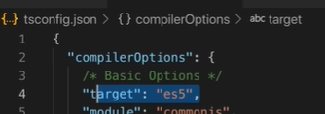
* 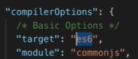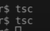

# Understanding TypeScript Libs

* Exclamation mark
* !! 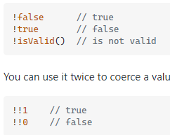
* It’s basic to tell typeScript don’t worry such a butto will exits we will get a value here
* 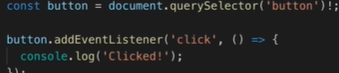
* 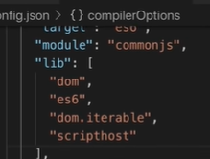

# More options:

* 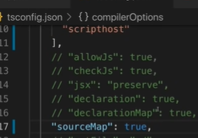 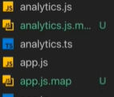
* 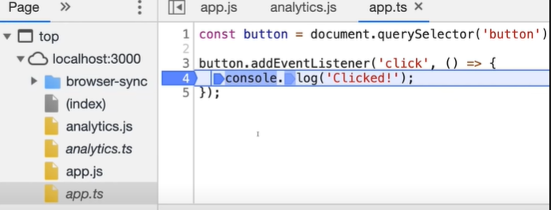
* Rootdir, outdir
* 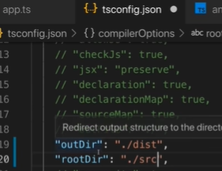
* removeComments
* noEmitOnError: true: we have an error in a file and if any file fails, to compile, no files will be emitted
* Strict compilation Options:
* 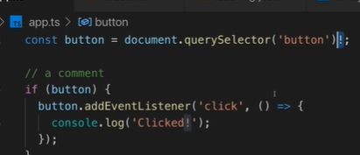

# Code Quality Options:

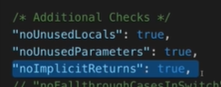

Error if variable declare but not use

Parameter declare but not use

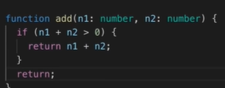

# Debugging with Visual Studio Code:

* 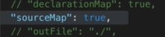
* &: intersection type in TypeScript:
* 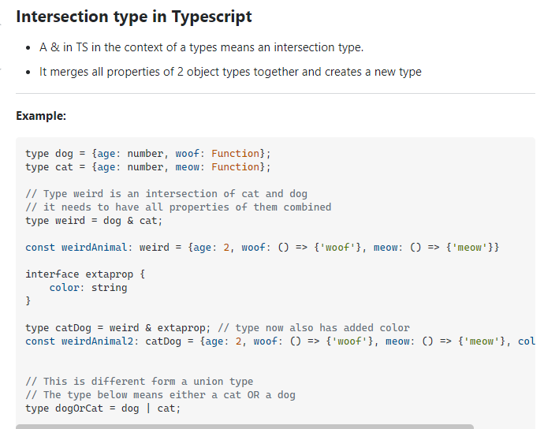 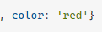

# Operator:

* ?: 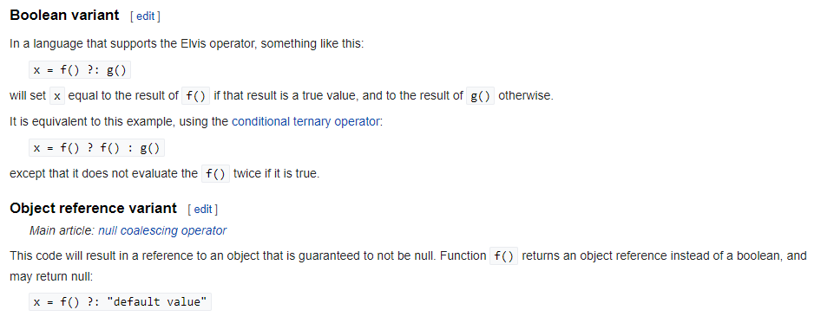

# React TypeScript:

## Getting started:

* 
* 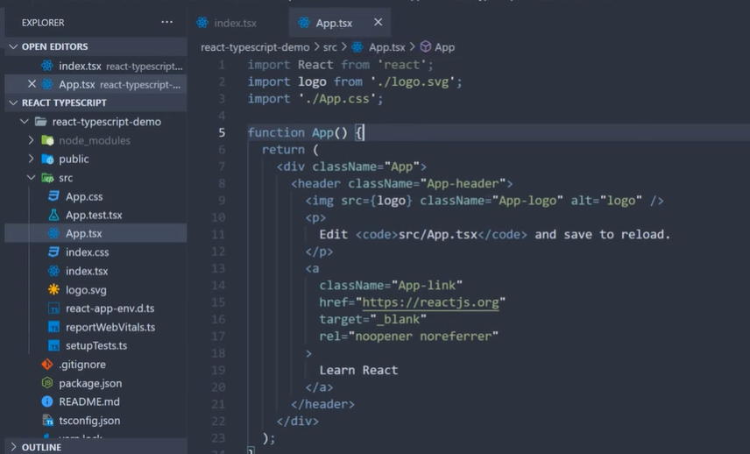
* 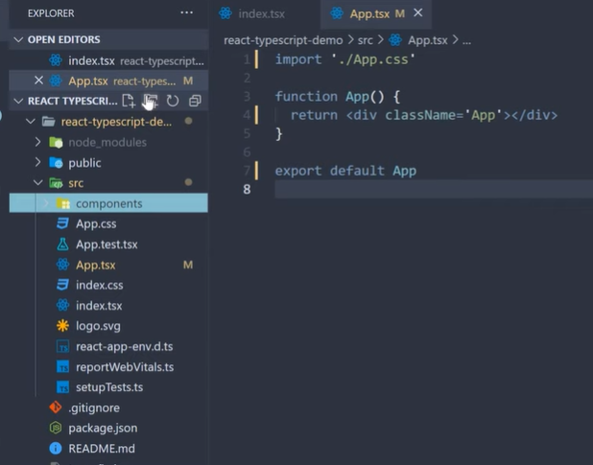

## Typing Props:

* 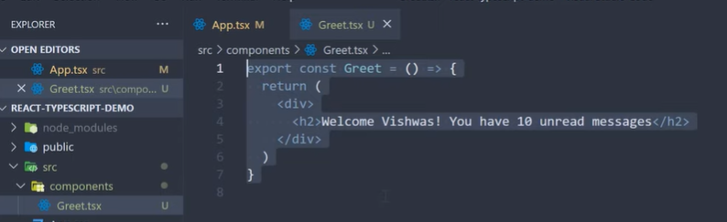
* 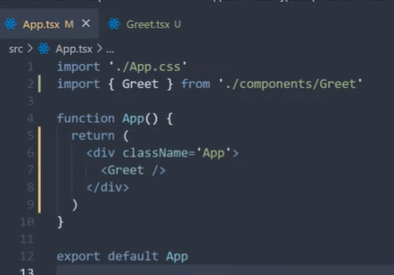 show on browser
* Props
* 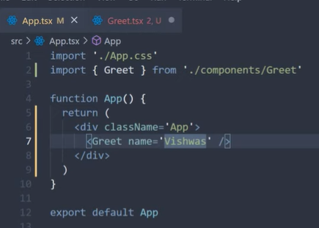
* 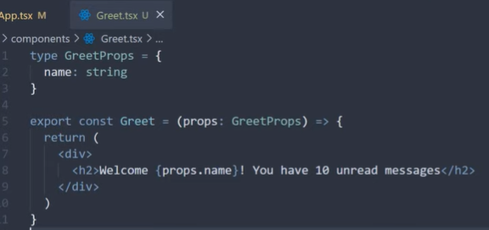

## Basic Props:

* 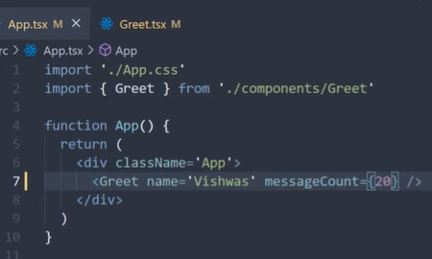
* 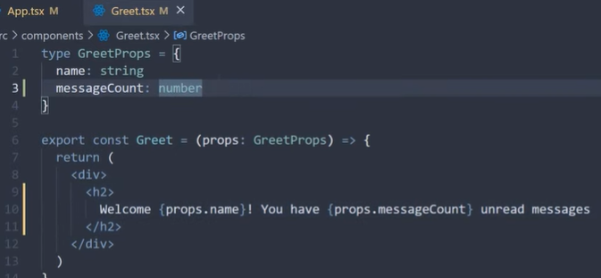
* Person.tsx
* Object prop
* 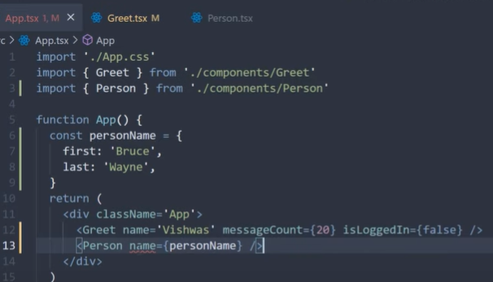
* 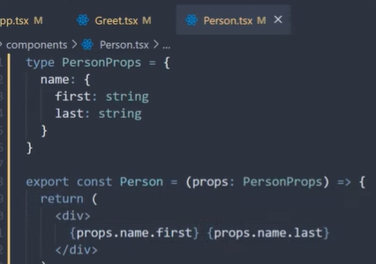
* personList.tsx
* 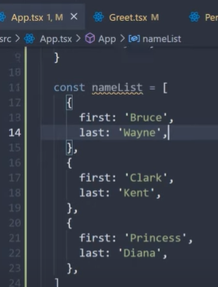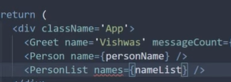
* 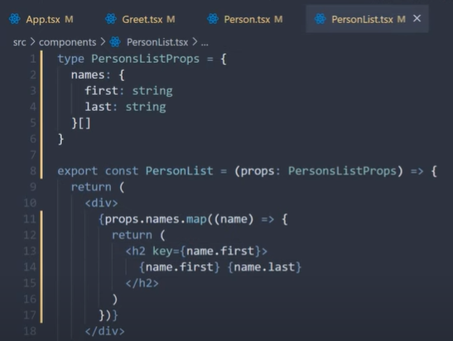

## Advanced Props:

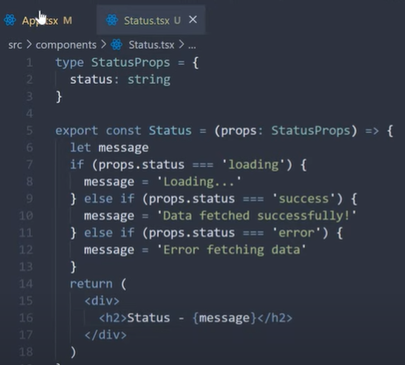

Children:

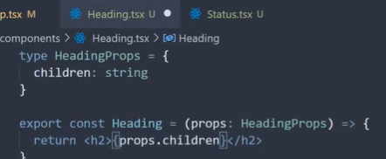

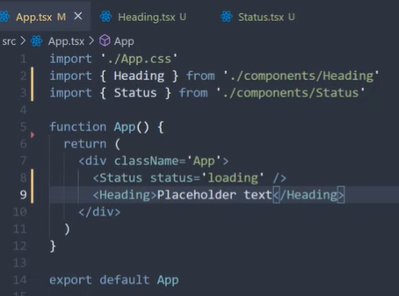

Element>elementChild</Element>

ReactNode

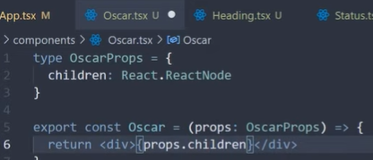

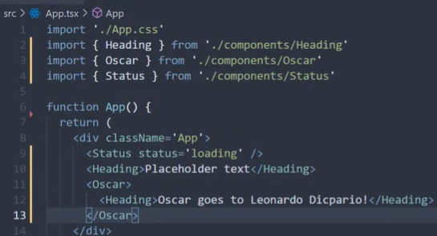

* Nếu truyền không đủ prop sẽ gặp lỗi: fix

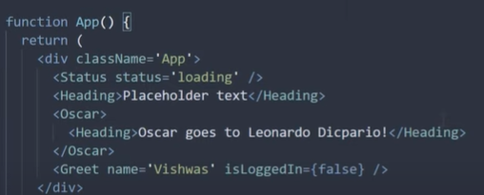

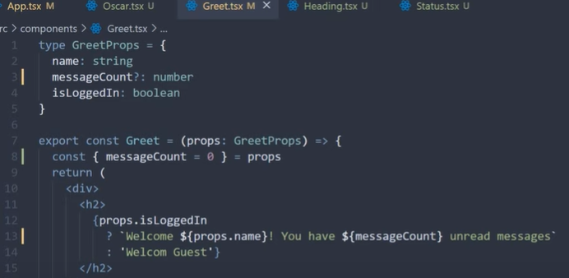

## Event Props:

* 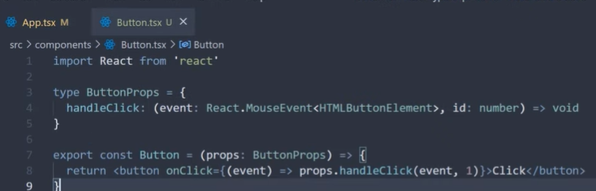
* 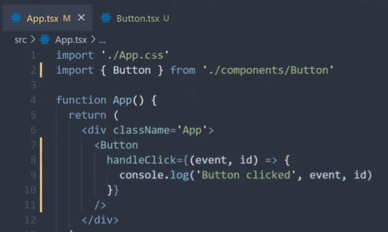

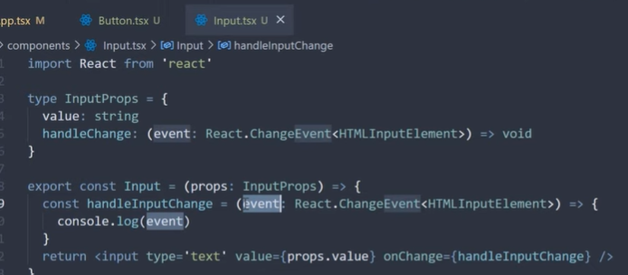

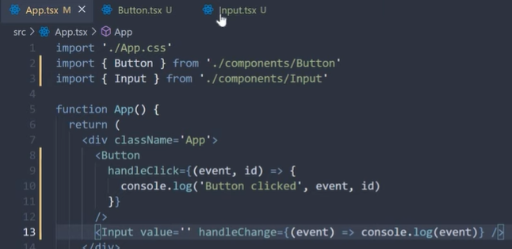

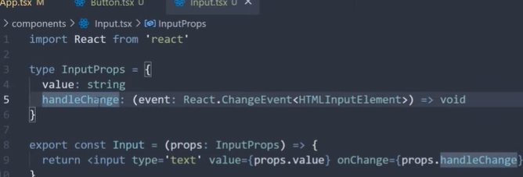

## Style Props:

* 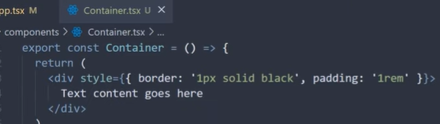
* 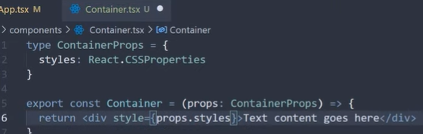
* 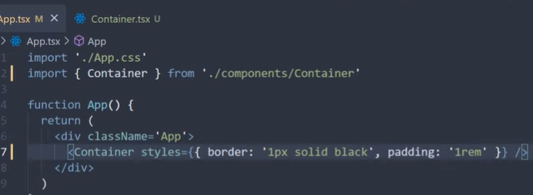

## Prop Types and Tips:

* One
* Destructor

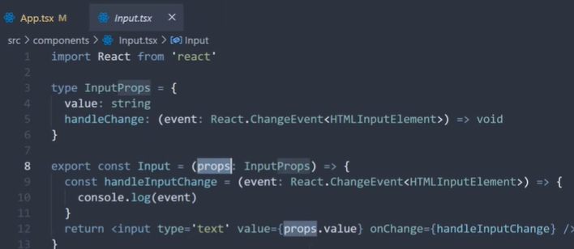to

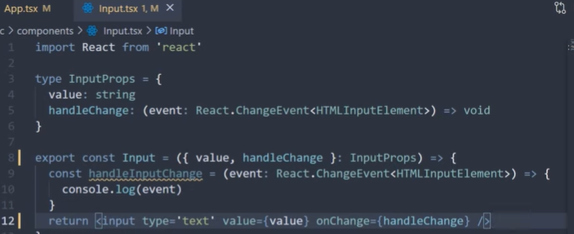

* Second
* Specific file with type

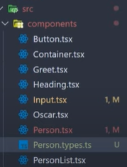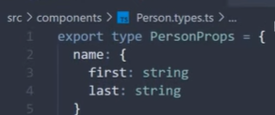

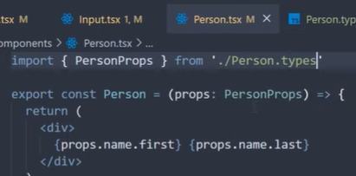

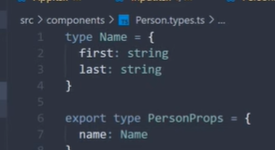

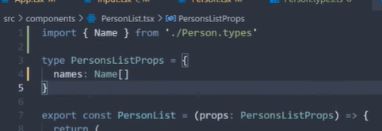

## useState Hook:

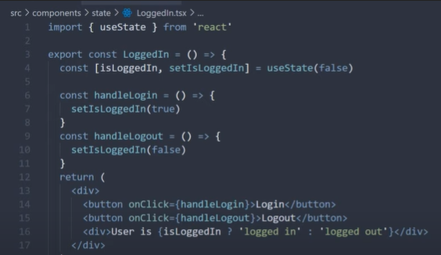

## useState Future Value:

<>

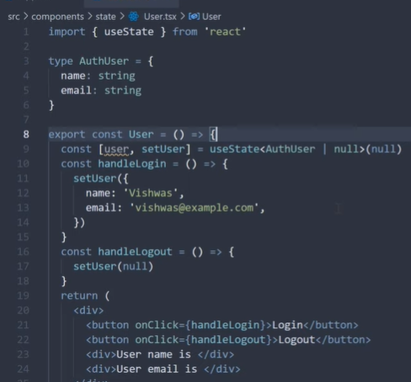

Because user can be null, so we use ?

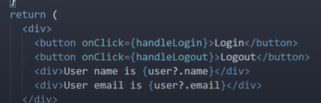

## useState Type Assertion:

as

but when we do specify null as one of the possible values we always have to make a check in our code that user is not null before accessing the properties, this of course is the right thing to do but sometimes you as the developer would know that user would be set to the correct value very soon after the component mounts and will be null in the future

for example, you would set the user in the user effect hook and let’s also assume you cannot log out in such cases you can I you want to use type assertion to let typescript know that the user is always of type auth user and won’t be null, for type assertion we use the asked keyword.

So instead of null or auth user, we specify just authuser and for the initial value, we set an empty **object as Authuser**

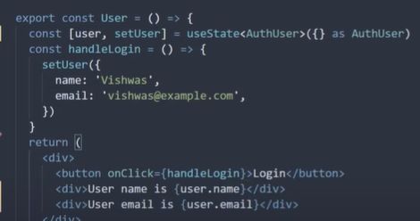

## userReducer Hook:

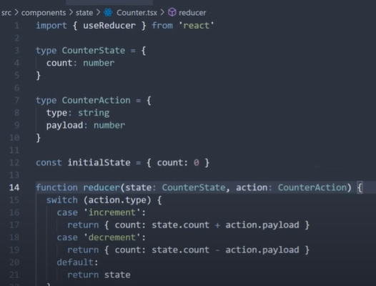

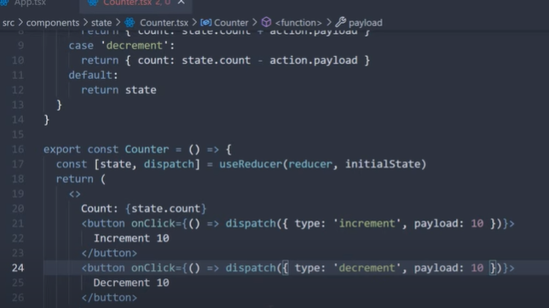

## useReducer Strict Action Types:

* 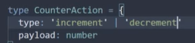 |
* 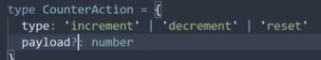
* 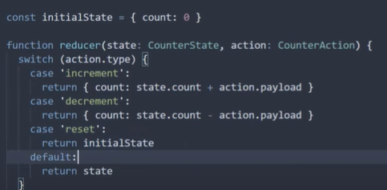
* 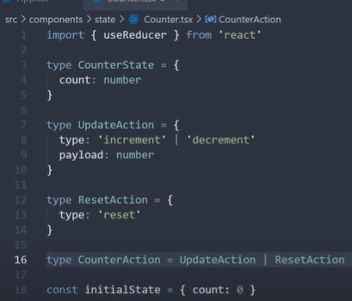
* 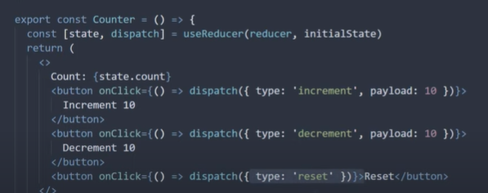

## useContext hook:

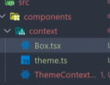 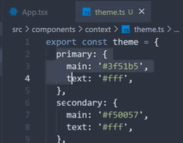

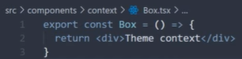

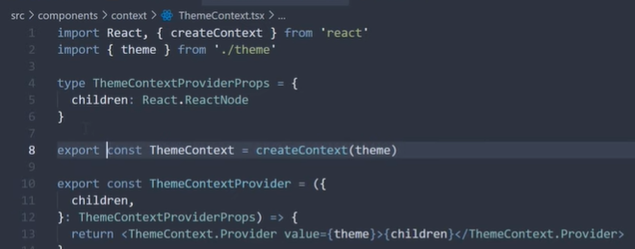

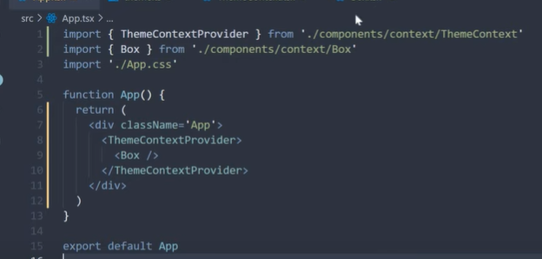

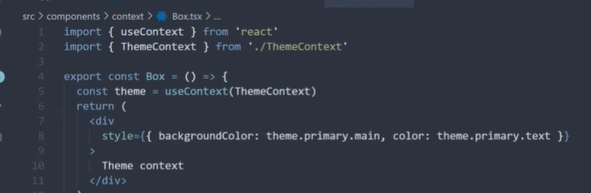

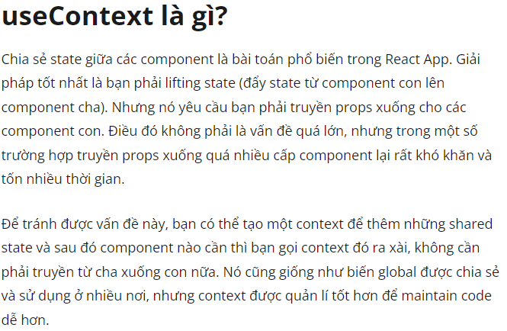

## useContext Future value:

* 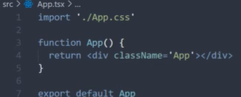 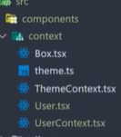 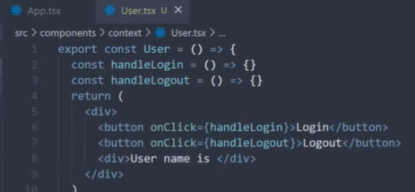

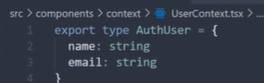

Start: